Dr Dan Shaffer BDS RDT PG Cert DentLaw
399 Luton road
Kinsbourne Green
Harpenden
AL5 3NF
T. 01582713400
E. info@puredentistry.co.uk

YourFutureSmiles Ltd Lab prescription

DENTIST___________________

DATE _____________________

 | PATIENT NAME: | DOB: | DATE DUE BACK:
DETAILS OF JOB (please circle)  CROWN/BRIDGE/BLEACHING TRAYS/NIGHT GUARD/  SPORTS GUARD/OTHER |  |  | 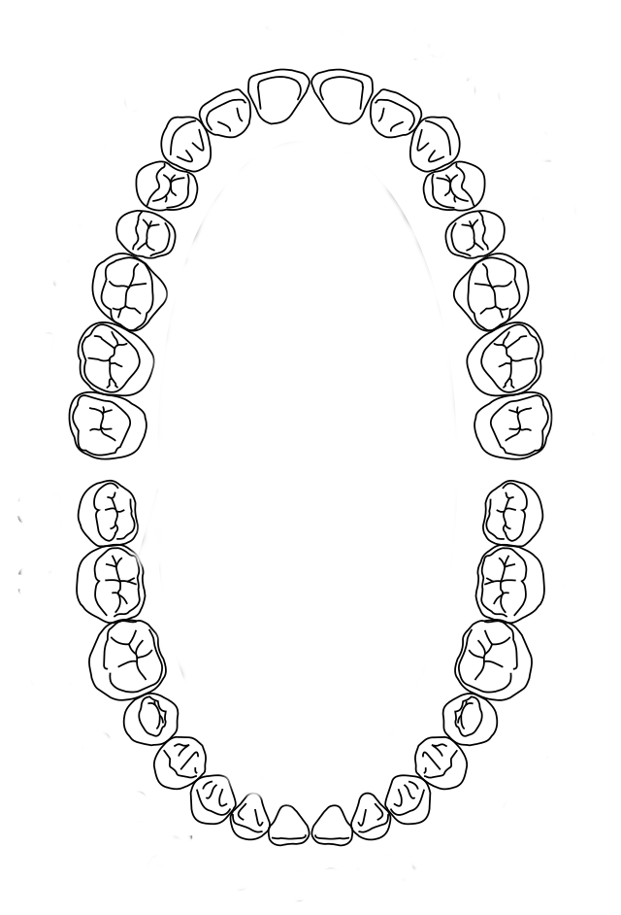  TOOTH NOTATION  SHADE: _____________

Technician Notes: | Reception notes;  Call Patient to Collect  Send to Patient  Deliver/Send to Dentist  Dentist to Pick Up  Other____________________________
Please select which service you require by ticking appropriate box:
Gold Service | 2 Working Days | + 100%
Silver Service | 5 Working Days | + 50%
Bronze Service | 10 Working Days | +0%

Statement: When signed and dated by a yourfuturesmiles technician as above, this device was manufactured for the exclusive use of the named patient for the specified Dental Practitioner and with described particular features. This product here packed conforms to the essential requirements set out in annex 1 of the EC Medical Device Directive 93/42/EEC and if any of these requirements are not fully met the details are documented on the reverse or attached and dispatched to the user.

MHRA reference no. CA015359

